LAI Preparation and Injection Techniques Presentation Appendix
Created by: Mackenzie Cullen, UConn School of Pharmacy, PharmD Candidate 2024 and Andria Latifi, UConn School of Pharmacy, PharmD Candidate 2024

Please note that the information presented in this appendix was transcribed from the manufacturer’s product information/package inserts.
- Medical information changes frequently; all information contained within this index is subject to change and new clinical updates.
- Please do not use this appendix as your sole source of information. Refer to the MOST CURRENT version of the Food and Drug Administration (FDA)-approved product labelling.
- Please watch for clinical updates from the manufacturer and/or the Food and Drug Administration.
Table of Contents

Antipsychotics
Abilify Maintena (aripiprazole) 3
Abilify Asimtufii (aripiprazole) 4
Aristada (aripiprazole lauroxil) 5
Aristada Initio (aripiprazole lauroxil) 7
Haldol Decanoate (haloperidol) 8
Invega Sustenna (paliperidone) 9
Invega Trinza (paliperidone) 11
Invega Hafyera (paliperidone) 12
Risperdal Consta (risperidone) 14
Perseris (risperidone) 15
Rykindo (risperidone) 16
Uzedy (risperidone) 17
Zyprexa Relprevv (olanzapine pamoate) 19
Prolixin Decanoate (fluphenazine) 20

Substance Use Disorder Treatment
Sublocade (buprenorphine) 21
Brixadi (buprenorphine) 23
Vivitrol (naltrexone) 25

References 26

Abilify Maintena (aripiprazole)

- Establish tolerability with oral aripiprazole prior to initiating Abilify Maintena
- Continue oral dosage for 14 days after initiating injection therapy
- Dosing:
  - Initial dose: 400 mg
  - Target dose: 400 mg
    - Can be reduced to 300 mg in patients with adverse reactions
  - Max recommended dose: 400 mg
  - Dosing Interval: Monthly
  - Loading dose: No
- CYP Drug Interaction Dosing:
  - Known CYP2D6 poor metabolizers:
    - Recommended both initial and maintenance dose is 300 mg monthly
  - CYP2D6 poor metabolizers taking concomitant CYP3A4 inhibitors:
    - Maintenance dose of 200 mg
  - Patients taking 400 mg of Abilify Maintena concomitantly with one of the following:
    - Strong CYP2D6 or CYP3A4 inhibitors: decrease dose 300 mg
    - CYP2D6 and CYP3A4 inhibitors: decrease dose 200 mg
    - CYP3A4 inducers: avoid use
  - Patients taking 300 mg of Abilify Maintena concomitantly with one of the following:
    - Strong CYP2D6 or CYP3A4 inhibitors: decrease dose to 200 mg
    - CYP2D6 and CYP3A4 inhibitors: decrease dose 160 mg
    - CYP3A4 inducers: avoid use
  - Dose adjustments are recommended in patients taking concomitant CYP2D6 inhibitors, 3A4 inhibitors, and/or CYP3A4 inducers for greater than 14 days
  - Note: 200 mg and 160 mg dosage adjustments can only be obtained by using the 300 mg and 400 mg strength vials
- Missed Doses:
  - If the 2nd or 3rd doses are missed:
    - More than 4 weeks and less than 5 weeks have elapsed since last injection:
      - Administer the injection as soon as possible
    - More than 5 weeks have elapsed since last injection:
      - Restart concomitant oral aripiprazole for 14 days with the next administered injection
  - If the 4th or subsequent doses are missed:
    - More than 4 weeks and less than 6 weeks have elapsed since the last injection:
      - Administer the injection as soon as possible.
    - More than 6 weeks have elapsed since last injection:
      - Restart concomitant oral aripiprazole for 14 days with the next administered injection

Abilify Asimtufii (aripiprazole)

- Establish tolerability with oral aripiprazole prior to initiating Abilify Asimtufii
- Dosing:
  - Initial Dose: 960 mg
    - Can be reduced to 720 mg in patients with adverse reactions
  - Dosing Interval: Every 2 months
- CYP Drug Interaction Dosing:
  - CYP2D6 Poor Metabolizers:
    - Known CYP2D6 poor metabolizer: 720 mg every 2 months
    - Known CYP2D6 poor metabolizer taking concomitant CYP3A4 inhibitors: avoid use
  - Patients taking 960 mg of Abilify Asimtufii:
    - Concomitant use with strong CYP2D6 inhibitors: decrease dose to 720 mg every 2 months
    - Concomitant use with strong CYP3A4 inhibitors: decrease dose to 720 mg every 2 months
    - Concomitant use with strong CYP2D6 and strong CYP3A4 inhibitors: avoid use
    - Concomitant use with CYP3A4 inducers: avoid use
  - Dose adjustments are recommended in patients taking concomitant CYP2D6 inhibitors, 3A4 inhibitors, and/or CYP3A4 inducers for greater than 14 days
- Missed Doses:
  - More than 8 weeks and less than 14 weeks have elapsed since last injection:
    - Administer next dose as soon as possible then once every 2 months schedule should be resumed
  - More than 14 weeks have elapsed since last injection:
    - Restart concomitant oral aripiprazole for 14 days with next administered injection

Aristada (aripiprazole lauroxil)

- For patients naïve to aripiprazole establish tolerability with oral aripiprazole prior to initiating treatment with Aristada
- There are two options for initiating treatment with Aristada
  - Option #1: Administer one injection of 675 mg of Aristada Initio and one
30 mg dose of oral aripiprazole in conjunction with the first Aristada
injection.
  - Option #2: Administer 21 consecutive days of oral aripiprazole in conjunction
with the first Aristada injection
- Dosing:

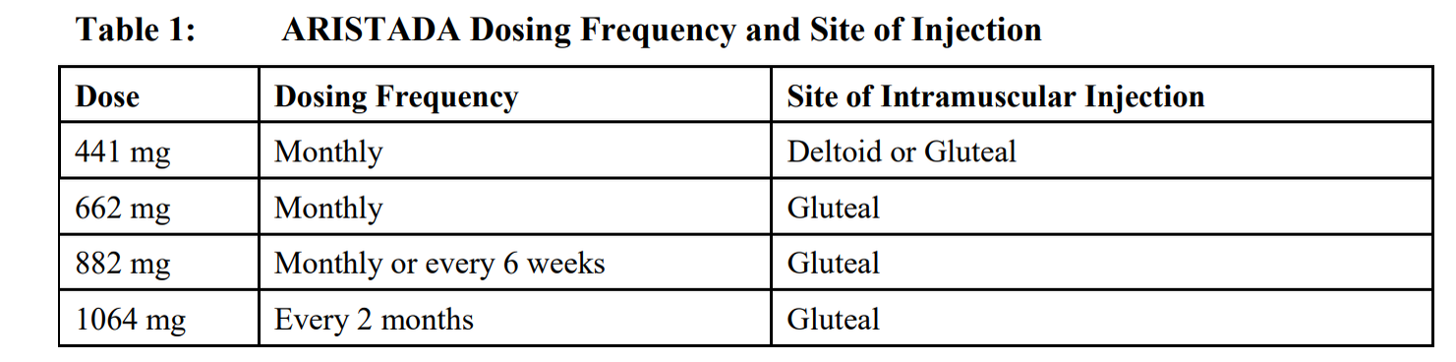

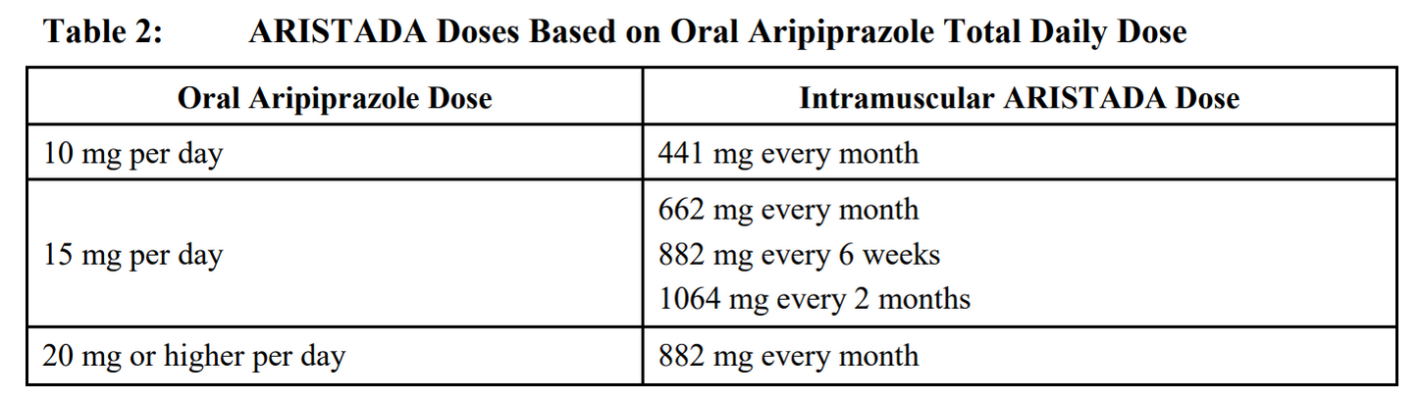

- CYP Drug Interaction Dosing for Aristada:
  - No dosage changes recommended for Aristada, if CYP450 modulators are added for less than 2 weeks
  - Strong CYP3A4 inhibitor:
    - Reduce dose to next lowest strength
    - No dosage adjustment necessary in patients taking 441 mg dose, if tolerated
  - Known poor metabolizers of CYP2D6:
    - No dosage adjustment necessary in patients taking 441 mg dose
    - Reduce dose to 441 mg from 662 mg, 882 mg, or 1064 mg
  - Strong CYP2D6 inhibitor:
    - No dosage adjustment necessary in patients taking 441 mg dose
    - Reduce dose to next lowest strength
  - Known poor metabolizers of CYP2D6: no dose adjustment needed
  - Both strong CYP3A4 inhibitor and strong CYP2D6 inhibitor:
    - No dosage adjustment necessary in patients taking 441 mg dose
    - Avoid using at 662 mg, 882 mg, or 1064 mg dose
  - CYP3A4 inducers:
    - Increase 441 mg dose to 662 mg
    - No dose adjustment for 662 mg, 882 mg, or 1064 mg dos

Table 3: ARISTADA Dose Adjustments with Concomitant CYP450 Modulator Use

Concomitant Medicine | Dose Change for ARISTADAa
Strong CYP3A4 Inhibitor | Reduce the dose of ARISTADA to the next lower strength. No dosage adjustment is necessary in patients taking 441 mg ARISTADA, if tolerated. For patients known to be poor metabolizers o[_CYP2D6: Reduce dose to  441 mg from 662 mg, 882 mg, or 1064 mg. No dosage adjustment is necessary in patients taking 441 mg ARISTADA, if tolerated.
Strong CYP2D6 Inhibitor | Reduce the dose of ARISTADA to the next lower strength. No dosage adjustment is necessary in patients taking 441 mg ARISTADA, if tolerated.  For patients known to be poor metabolizers o[ CYP2D6: No dose adjustment required.
Both Strong CYP3A4 Inhibitor and Strong CYP2D6 Inhibitor | Avoid use for patients at 662 mg, 882 mg, or 1064 mg dose. No dosage adjustment is necessary in patients taking 441 mg ARISTADA, if tolerated.
CYP3A4 Inducers | No dose adjustment for 662 mg, 882 mg, or 1064 mg dose· increase the 441 mg dose to 662 mg.
' For the 882 mg dose administered every 6 weeks and the 1064 mg administered every 2 months, the next lower strength should be 441 mg administered monthly.

- Missed Dose:

Table 4: Aristada Re-initiation After Missed Doses

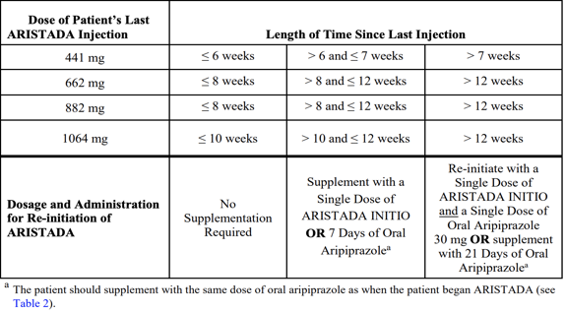

Aristada Initio (aripiprazole)

- If patient has never taken aripiprazole, establish tolerability with oral aripiprazole prior to treatment. May take up to 2 weeks.
- Aristada Initio is only to be used as a single dose to initiate Aristada treatment or as a single dose to re-initiate Aristada treatment following a missed dose of Aristada.
- Aristada Initio is not for repeated dosing; it is not interchangeable with ARISTADA due to differing pharmacokinetic profiles
- Dosing:
  - Initial Dose: 675 mg on first day of initial Aristada injection.
  - Initiation:
    - Administer one 675 mg injection of Aristada Initio in the deltoid or gluteal muscle and one 30 mg dose of oral aripiprazole
    - The first Aristada injection may be administered on the same day as Aristada Initio or up to 10 days thereafter
  - Dosing interval: One time loading dose
  - Loading dose: 675 mg
- CYP Drug interaction Dosing for Aristada Initio:
  - Only available at single strength therefore dosage adjustments not possible
  - Avoid use in patients who are known CYP2D6 poor metabolizers or taking strong CYP3A4 inhibitors, strong CYP2D6 inhibitors, or strong CYP3A4 inducers
- Missed Dose: N/A

Haldol Decanoate (haloperidol)

- Continue oral dosage and discontinue within 1 month
- Dosing:
  - Initial dose:
    - 10-20 times the previous daily oral dose
    - Initial dose should not exceed 100 mg
    - If initial dose exceeds 100 mg administer as 2 injections:
      - 100 mg on day 1 followed by the balance in 3 to 7 days
  - Target dose:
    - 10-15 times the previous daily oral dose
    - May administer >100 mg per injection if deemed necessary
  - Max recommended dose: 450 mg
  - Dosing Interval: Every 4 weeks
  - Loading dose: Yes
- CYP Drug Interaction Dosing:
  - CYP3A4 and CYP2D6 inhibitors may increase concentrations of Haldol
    - If patient is taking either CYP3A4 or CYP2D6 inhibitors concomitantly with Haldol, consider decreasing dose of Haldol
  - CYP3A4 inducers may decrease concentration of Haldol
    - Recommended to monitor patients taking both and if necessary, increase dose of Haldol or adjust dosing interval
  - Haldol is an inhibitor of CYP2D6 and may increase concentration of substrate drugs when co-administered
- Missed Dose:
  - If the 2nd or 3rd dose are missed:
    - Administer no later than 5 weeks after the last injection
  - If the 4th or subsequent doses are missed:
    - Administer no later than 8 weeks after last injection

Invega Sustenna (paliperidone)

- Establish tolerability with oral paliperidone or oral risperidone prior to initiation of treatment
- Oral medication overlap is not required.
- Dosing:
  - Initial dose: Day 1: 234 mg

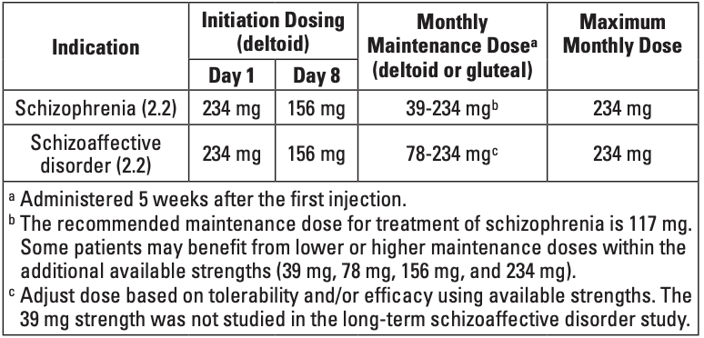

  - Target dose: 117 mg (max 234 mg)
  - Dosing Interval: Every 4 weeks
  - Loading dose: Yes
- Renal Impairment Dosing:
  - Moderate to severe renal impairment (CrCl<50mL/min)
    - Not recommended
  - Mild renal impairment (CrCl>50mL/min-80mL/min):
    - Administer 156 mg on day 1 and 117 mg on day 8; both in deltoid muscle, followed by recommended monthly maintenance dose of 78 mg
    - Adjust monthly maintenance dose based on tolerability and/or efficacy within strengths of 39 mg, 78 mg, 117 mg, or 156 mg
    - Maximum monthly dose: 156 mg
- CYP Drug Interaction Dosing:
  - Coadministration with strong CYP34 and/or p-glycoprotein inducers
    - Avoid use during the 1-month dosing interval, if possible
    - If necessary, consider managing the patient with paliperidone extended release tablets
- Missed Doses:
  - To avoid missing doses:
    - Patients may be given the 2nd dose 4 days before or after the 1-week time point
    - Patients may be given the 3rd and subsequent injections up to 7 days before or after the monthly time point

  - Management of a Missed 2nd Initiation Dose:

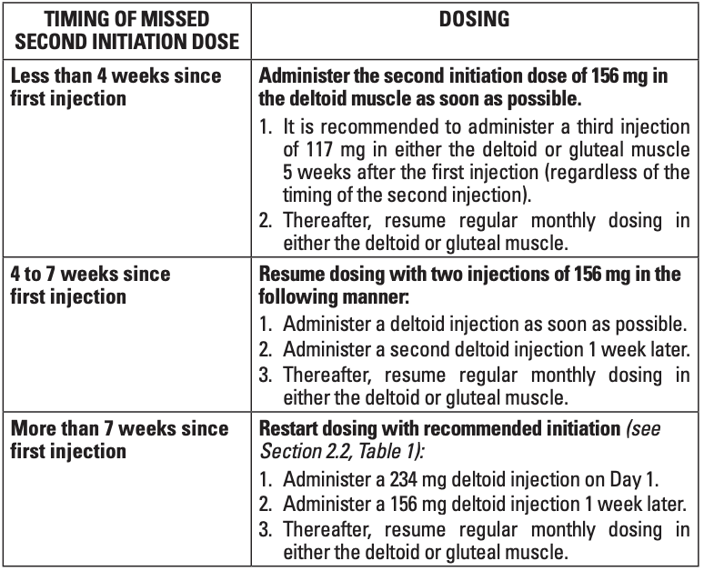

  - Management of a Missed Maintenance Dose:

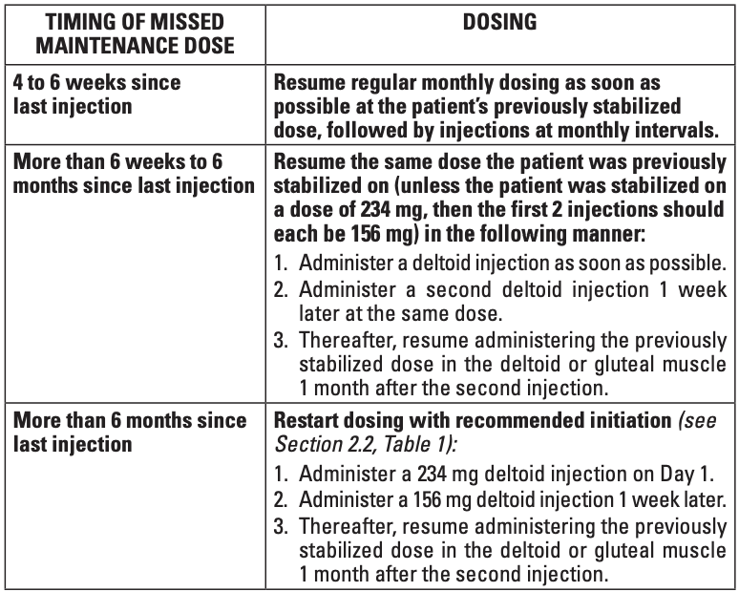

Invega Trinza (paliperidone)

- Can only be initiated after the patient has been treated with the 1-month paliperidone palmitate extended-release injectable suspension for at least 4 months
- Dosing:
  - Initial dose: Based on Invega Sustenna dose

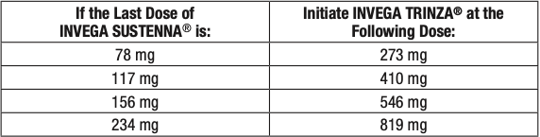

  - Target Dose: Same dosing range as initial doses; based on individual patients
  - Dosing Interval: Every 3 months
  - Loading dose: Must start with Invega Sustenna
- CYP Drug Interaction Dosing:
  - Strong inducers of CYP3A4 and p-glycoprotein
    - If possible, avoid use during the 3-month dosing interval
- Missed Dose:
  - Patients may be given the injection up to 2 weeks before or after the 3-month time point
  - If more than 3.5 months, but less than 4 months have elapsed since the last injection:
    - Administer the next dose as soon as possible then continue with the 3-month injections following this dose
  - If 4-9 months have elapsed since the last injection use the following table to reinitiate treatment:

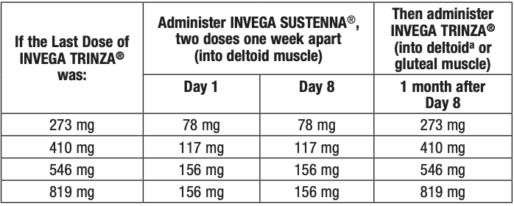

  - If more than 9 months have elapsed since the last injection:
    - Reinitiate treatment with the 1-month paliperidone palmitate extended-release injectable suspension for 4 months and then Invega Trinza may be resumed

Invega Hafyera (paliperidone)

- Can only be used after once-a-month paliperidone palmitate extended-release injectable suspension for at least four months or every-three-month paliperidone palmitate extended-release injectable suspension for at least one three-month cycle
- Dosing:
  - Initial dose: Based on Sustenna or Trinza dose
    - Initiate when the next once-a-month or every 3-month paliperidone palmitate extended-release injectable suspension dose is scheduled
      - Once-a-month palmitate extended-release injectable suspension dose
        - PP1M: 156 mg; give the 1092 mg dose of Invega Hafyera
        - PP1M: 234 mg; give the 1560 mg dose of Invega Hafyera
      - Every 3-month palmitate extended-release injectable suspension
        - PP3M: 546 mg; give the 1092 mg dose of Invega Hafyera
        - PP3M: 892 mg; give the 1560 mg dose of Invega Hafyera
  - Target Dose: Same dosing range as initial doses
  - Dosing Interval: Every 6 months
  - Loading dose: Must start with Invega Sustenna
- CYP Drug Interaction Dosing:
  - Strong inducers of CYP3A4 and p-glycoprotein:
    - If possible, avoid use during the 6-month dosing interval
- Missed Dose:
  - To avoid missed dose, patients may be given the injection up to 2 weeks before or 3 weeks after the scheduled 6-month dose
  - If more than 6 months and 3 weeks but less than 8 months have elapsed since the last injection
    - Do not administer the next dose of Invega Hafyera and use the reinitiation regimen according to the table below:

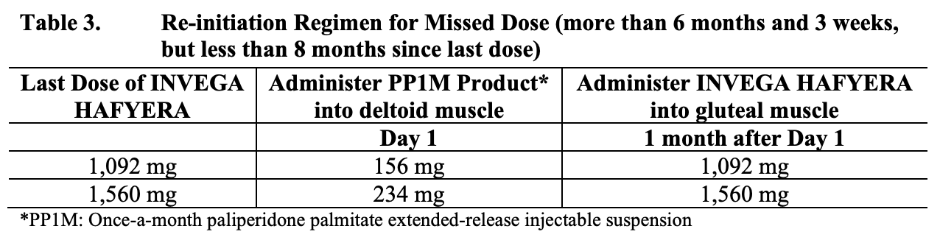

- If 8-11 months have elapsed since the last injection:
  - Do not administer the next dose of Invega Hafyera and use the reinitiation regimen according to the table below:

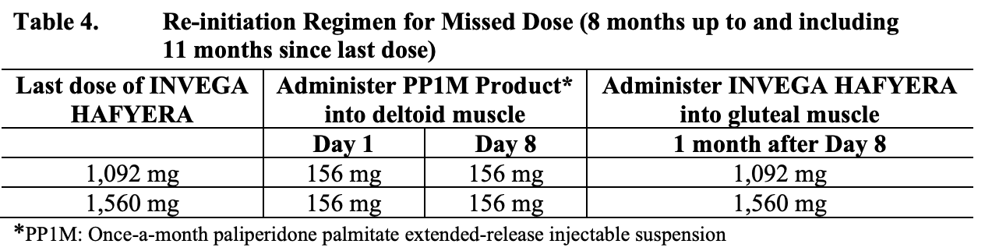

- If more than 11 months have elapsed since the last injection
  - Reinitiate treatment with a PP1M product for 4 months then Invega Hafyera can be resumed

Risperdal Consta (risperidone)

- Establish tolerability with oral risperidone prior to initiating if patient has never taken oral Risperdal
- Continue oral medication for 3 weeks following first injection and then discontinue
- Dosing:
  - Initial Dose: 25 mg
  - Target Dose: 25-50 mg
  - Max recommended dose: 50 mg
  - Dosing Interval: Every 2 weeks
  - Loading Dose: No
- CYP Drug Interaction Dosing:
  - CYP3A4 inducers: may cause decrease in plasma concentration and therefore dose reduction of Risperdal Consta may be needed
    - Patients may be placed on lower dose 2-4 weeks before the planned discontinuation of CYP3A4 inducers
    - If being treated with 25 mg Risperdal Consta, it is recommended to continue treatment with the 25 mg dose unless clinical judgment necessitates lowering the dose to 12.5 mg or interruption of treatment
- Missed Dose:
  - Dosing will depend on steady-state plasma concentration of Risperdal Consta
  - If steady state has been achieved and only 3-6 weeks have passed since last injection, next dose should be given as soon as possible
    - If more than 6 weeks have passed since last injection risperidone long-acting should be initiated as soon as possible and 3 weeks of coverage with an oral antipsychotic should be given
  - If steady state has not been achieved, Risperdal Consta should be reinitiated as soon as possible, and oral antipsychotic coverage for 3 weeks should be given

Perseris (risperidone)

- Establish tolerability with oral risperidone prior to initiating if patient has never taken oral Risperdal
- Supplementation with oral risperidone is not recommended
- Dosing:
  - Initial dose: 90 mg or 120 mg
    - 90 mg corresponds to 3 mg/day of oral risperidone
    - 120 mg corresponds to 4 mg/day of oral risperidone
    - Patient stable on oral risperidone doses lower than 3 mg/day or higher than 4mg/day are not candidates for Perseris
  - Dose interval: Once a month, do not administer more than one dose per month
  - Loading dose: No
- CYP Drug Interactions
  - Strong CYP2D6 Inhibitors
    - Inhibitors may increase the plasma concentration of risperidone
    - If fluoxetine or paroxetine are being considered, patients may be placed on lower dose of Perseris (90 mg) between 2 to 4 weeks before planned start of fluoxetine or paroxetine therapy
    - If fluoxetine or paroxetine is initiated in patients receiving 90 mg, continue treatment with 90 mg unless clinical judgment necessities interruption of Perseris
  - Strong CYP3A4 Inducers
    - Inducers may decrease the plasma concentration of risperidone
    - At initiation of therapy with inducer, patient should be monitored closely for 4 to 8 weeks
    - In patients receiving Perseris 90 mg, consider increasing the dose to 120 mg
    - In patients receiving Perseris 120 mg, additional oral risperidone therapy may need to be considered.
- Missed dose: If patient misses a dose, they should receive next dose as soon as possible

Rykindo (risperidone)

- Establish tolerability with oral risperidone prior to initiating treatment with Rykindo.
- Administer first dose of Rykindo along with 7 days of oral risperidone.
- Dosing for Schizophrenia and Bipolar I Disorder
  - No loading dose
  - Initial dose: 25 mg every 2 weeks
  - Target dose: 37.5 mg or 50 mg
  - Max dose: 50 mg every 2 weeks
- CYP Drug Interactions Dosing:
  - CYP3A4 Inducers may decrease plasma concentrations of risperidone.
    - Dose of Rykindo needs to be titrated accordingly for patients receiving concomitant inducers, especially during initiation or discontinuation of therapy
    - Patients should be monitored during the first 4-8 weeks.
    - Dose increase or additional oral Risperdal may be considered
    - On discontinuation of 3A4 inducer, dose of Rykindo should be re-evaluated and decreased if necessary.
    - Patients may be placed on lower dose between 2-4 weeks before the planned discontinuation of CYP3A4 inducers
    - If being treated with 25 mg of Rykindo and discontinuing CYP3A4 inducer, it is recommended to continue the 25 mg dose unless clinical judgment necessitates lowering the dose to 12.5 mg or interruption of treatment
  - CYP2D6 have shown to increase plasma concentration of risperidone
    - fluoxetine did not affect the plasma concentration
    - paroxetine lowered the concentration by roughly 10%
    - Dose of Rykindo needs to be titrated accordingly when co-administering fluoxetine or paroxetine
    - If initiating fluoxetine or paroxetine patients may need to be placed on lower dose of Rykindo for 2-4 weeks before planned start of fluoxetine or paroxetine therapy to adjust for expected increase in plasma concentrations
    - If patient is already receiving fluoxetine or paroxetine and Rykindo is initiated, a starting dose of 12.5 mg can be considered
    - If being treated with 25 mg of Rykindo and initiating fluoxetine or paroxetine, it is recommended to continue the 25 mg dose unless clinical judgment necessitates lowering the dose to 12.5 mg or interruption of treatment
- Missed Dose:
  - There is no data to address reinitiation of treatment in patients who have discontinued the drug.
  - When restarting in patients who have had an interval off treatment with Rykindo, the previously established dose should be reinitiated if there is no change in patients’ medical condition
  - Supplementation with oral risperidone is required
Uzedy (risperidone)

- Establish tolerability with oral risperidone prior to initiating Uzedy
- To initiate Uzedy you must switch from oral daily risperidone and start Uzedy on the day after the last dose of oral therapy
- Oral dose supplementation is not recommended when switching
- Dosing:
  - Initial: based on previous oral dose

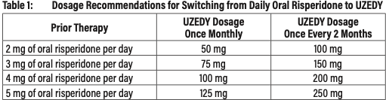

  - Dose Interval: Once monthly or once every 2 months
  - Loading dose: No
  - Patients can switch between doses of once monthly and once every 2 months Uzedy
    - Administer first dose of new dosing regimen on next scheduled date of administration in original dosing regimen and revise future dose administration schedule to reflect change
- Renal or Hepatic Impairment Dosing
  - Prior to initiating Uzedy in patients with renal or hepatic impairment titrate with oral risperidone to at least 2 mg once daily
  - Following oral titration, the recommended dose of Uzedy is 50 mg once monthly
- CYP Enzyme Drug Interactions
  - Strong CYP2D6 Inhibitors
    - Inhibitors may increase the plasma concentrations of risperidone
    - If fluoxetine or paroxetine are being considered, place patients on a lower dose of Uzedy prior to the planned start of fluoxetine or paroxetine therapy
    - If fluoxetine or paroxetine is initiated in patients receiving the recommended dose of 50 mg once monthly or 100 mg once every 2 months of Uzedy, continue treatment with these doses unless clinical judgment necessitates interruption of Uzedy
  - Strong CYP3A4 Inducers
    - Inducers may decrease the plasma concentration of risperidone
    - At initiation of therapy with inducer, patient should be monitored closely for 4 to 8 weeks, dose increase additional oral risperidone, may be considered.
    - If discontinuing strong CYP3A4 inducer, re-evaluated the dosage of Uzedy or any additional oral risperidone therapy and, if necessary, decrease to adjust for the expected increase in plasma concentration of risperidone.
- Missed Dose:
  - When a dose is missed, administer the next Uzedy injection as soon as possible.
  - Do not administer more frequently than recommended.

Zyprexa Relprevv (olanzapine pamoate)

- Establish tolerability with oral olanzapine prior to initiating treatment
- Dosing: Gluteal injections only

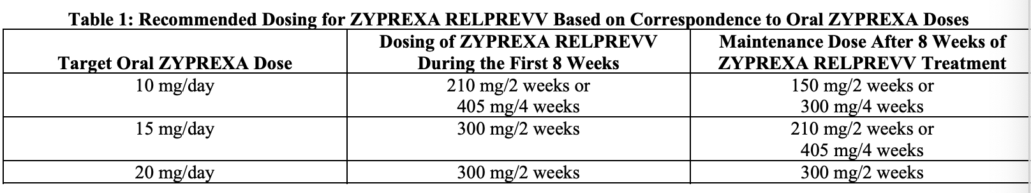

  - Dosing Interval: Every 2-4 weeks
  - Loading Dose: Yes
- CYP Drug Interaction Dosing:
  - CYP1A2 inducers: increases clearance of Zyprexa Relprevv
  - CYP1A2 inhibitors: decreases clearance of Zyprexa Relprevv
    - Lower doses should be considered in patients receiving concomitant treatment
  - CYP2D6 inhibitors: causes a small decrease in Zyprexa Relprevv clearance
    - Dose modification not routinely recommended
  - CYP1A2 or Glucuronyl Transferase Enzyme inducers: may increase Zyprexa Relprevv clearance
- Missed Dose:
  - No recommendation in package insert, suggested approaches based on pharmacokinetics and literature go as follows:
    - If a maintenance dose if missed and steady state has not been reached (<3 months of therapy), administer the recommended loading dose for 8 weeks
    - If a maintenance dose is missed and steady state has been reached (>3 months of therapy) and it has been < 2 months since the last injection, administer the missed dose as soon as possible

Prolixin Decanoate (fluphenazine)

- If patient has no history of taking phenothiazines, it is recommended to initially treat with shorter acting form of fluphenazine to establish tolerability
  - Decrease dose of oral fluphenazine, or current antipsychotic by half after initial injection and consider discontinuation of oral therapy after second injection
- Dosing:
  - Initial Dose: 12.5 mg to 25 mg
  - Target Dose: 12.5-50 mg
  - Max recommended dose: 100 mg
  - Dosing Interval: every 4 weeks
  - Loading dose: no
- CYP Drug Interaction Dosing:
  - Strong CYP2D6 Inhibitors
    - May increase the serum concentration of fluphenazine
    - It is recommended to monitor therapy
- Missed Dose:
  - For patients scheduled to receive the injections every 4 weeks and who have received at least 2 previous injections as scheduled: the next dose should be administered no later than 8 weeks after the last injection

Sublocade (buprenorphine)

- Initiation of treatment should only be done following induction and dose-adjustment with transmucosal buprenorphine-containing product delivering equivalent of 8 to 24 mg of buprenorphine daily. Patient may only be transitioned to Sublocade after a minimum of 7 days
- Dosing
  - Initial dose: 300 mg monthly for first two months
  - Maintenance dose: 100 mg monthly
    - May be increased to 300 mg monthly if patient does not have clinical response
- Drug Interaction Dosing
  - CYP3A4 Inducers
    - If patient is transferred to Subcolade treatment from transmucosal buprenorphine used concomitantly with CYP3A4 inducers, plasma buprenorphine levels should be monitored
    - If patient is already on Sublocade and require treatment of CYP3A4 inducer, patient should be monitored for withdrawal
    - Patient should be transitioned back to buprenorphine formulation that permits dose adjustments if Sublocade dose is inadequate in the absence of the concomitant medication and the concomitant medication cannot be reduced or discontinued
    - Patient should be monitored for signs and symptoms of over medication if stabilized on Subcolade, but concomitant medication is discontinued
  - CYP3A4 Inhibitors
    - If patient is transferred to Subcolade treatment from transmucosal buprenorphine used concomitantly with CYP3A4 inhibitors, plasma buprenorphine levels should be monitored
    - If patient is already on Sublocade and require newly-initiated treatment with CYP3A4 inhibitors, patient should be monitored for signs and symptoms of over-medication
    - Within 2 weeks of SUBLOCADE administration, if signs and symptoms of buprenorphine toxicity or overdose occur but the concomitant medication cannot be reduced or discontinued, it may be necessary to remove the depot and treat the patient with a formulation of buprenorphine that permits dose adjustments
  - Serotonergic Drugs
    - If concomitant use is warranted monitor patient for signs and symptoms for serotonin syndrome; particularly during treatment initiation, and during dose adjustment of the serotonergic drug
    - Use of Sublocade is not recommended for patients taking MAOIs or within 14 days of stopping treatment
  - Benzodiazepines and CNS Depressants
    - Cessation of benzodiazepines or other CNS depressants are preferred
    - Taper may be appropriate in higher level of care

- Missed Dose
  - If patient misses dose, they should receive next dose as soon as possible, with the following dose given no less than 26 days later
  - Occasional delays in dosing up to 2 weeks are not expected to have a clinically significant impact on treatment effect

Brixadi (buprenorphine)

- Patients currently being treated with other buprenorphine-containing products can start treatment with either Brixadi (weekly) or Brixadi (monthly)
- Patients not currently receiving buprenorphine treatment should begin with a test dose of 4 mg transmucosal buprenorphine to establish tolerability of buprenorphine without precipitating withdrawal and then transition to Brixadi (weekly)
- Dosing:
  - Weekly Formulation: Administer in 7-day intervals
  - Monthly Formulation: Administer in 28-day intervals
  - If patient is currently not receiving buprenorphine treatment recommended dose is 24 mg titrated up over the first week of treatment
    - If the dose of transmucosal buprenorphine is tolerated without precipitated withdrawal, administer the first dose of Brixadi (weekly), 16 mg.
    - Administer an additional dose of 8 mg Brixadi (weekly) within 3 days of the first dose to achieve the recommended 24 mg Brixadi (weekly) dose.
  - If patient is currently receiving buprenorphine treatment, they may directly be switched to either weekly or monthly formulation
    - 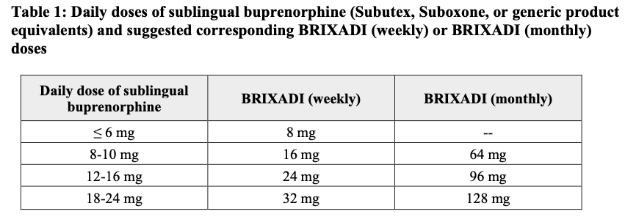
  - Switching between weekly and monthly formulations
    - Patients may switch based on clinical judgment
    - Recommended dosing when transitioning:
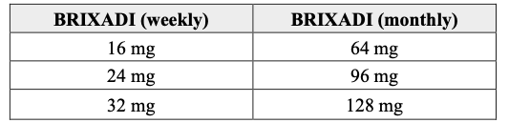

- CYP Drug interactions:
  - CYP3A4 Inducers
    - Patients converted to Brixadi treatment from a regimen of transmucosal Buprenorphine used concomitantly with CYP3A4 inducers: Monitor to ensure that the plasma buprenorphine level provided by Brixadi is adequate.
    - Patients already on Brixadi who require newly initiated treatment with a CYP3A4 inducer: Monitor for withdrawal, adjust dose of Brixadi if inadequate and CYP3A4 inducer cannot be reduced or discontinued
    - Patients Stabilized on Brixadi in the setting of concomitant medication that is a CYP3A4 inducer, and the concomitant medication is discontinued: monitor for signs and symptoms of over-medication, consider reducing dose of Brixadi if excessive in absence of inducer
  - CYP3A4 Inhibitors
    - Same monitoring as inducers
  - Serotonergic Drugs
    - If concomitant use is warranted monitor patient for signs and symptoms for serotonin syndrome; particularly during treatment initiation, and during dose adjustment of the serotonergic drug
    - If serotonin syndrome is suspected discontinue Brixadi
    - Use of Brixadi is not recommended for patients taking MAOIs or within 14 days of stopping treatment
- Missed dose: If patient misses a dose, they should receive next dose as soon as possible

Vivitrol (naltrexone)

- If being used for alcohol use disorder, patient should not be actively drinking at time of initial administration
- Prior to initiating VIVITROL, an opioid-free duration of a minimum of 7–10 days is recommended for patients, to avoid precipitation of opioid withdrawal that may be severe enough to require hospitalization
- Dosing:
  - Initial dose: 380 mg
  - Dosing interval: Every 4 weeks or once a month
  - Maintenance dose: 380 mg
- CYP Enzyme Interactions
  - Vivitrol is not a substrate for CYP enzymes, therefore inhibitor of inducers CYP enzymes are unlikely to change clearance of Vivitrol
- Drug Interactions:
  - Antagonizes effects of opioid-containing medicines such as cough and cold remedies, antidiarrheal preparations, and opioid analgesics
    - Patients will not benefit from these medications while taking Vivitrol
- Missed Dose: If patient misses a dose, they should receive next dose as soon as possible

References

- Abilify Maintena [package insert]. Rockville, MD: Otsuka Pharmaceutical Company; 2016. https://www.accessdata.fda.gov/drugsatfda_docs/label/2016/202971s008lbl.pdf
- Abilify Asimtufii [package insert]. Rockville, MD: Otsuka Pharmaceutical Company; 2023. https://www.accessdata.fda.gov/drugsatfda_docs/label/2023/217006s000lbl.pdf
- Aristada [package insert]. Waltham, MA: Alkermes Inc.; 2020. https://www.aristadahcp.com/downloadables/ARISTADA-PI.pdf
- Aristada Initio [package insert]. Waltham, MA: Alkermes Inc.; 2020. https://www.aristadahcp.com/downloadables/ARISTADA-INITIO-PI.pdf
- Haldol Decanoate [package insert]. Titusville,NJ: Janssen Pharmaceuticals Company; 2020.https://www.janssenlabels.com/package-insert/product-monograph/prescribing-information/HALDOL+Decanoate-pi.pdf
- Invega Sustenna [package insert]. Titusville, NJ: Janssen Pharmaceuticals Company; 2018. https://www.janssenlabels.com/package-insert/product-monograph/prescribing-information/INVEGA+SUSTENNA-pi.pdf
- Invega Trinza [package insert]. Titusville, NJ: Janssen Pharmaceuticals Company; 2018. https://www.janssenlabels.com/package-insert/product-monograph/prescribing-information/INVEGA+TRINZA-pi.pdf
- Invega Hafyera [package insert]. Titusville, NJ: Janssen Pharmaceuticals Company; 2021. https://www.accessdata.fda.gov/drugsatfda_docs/label/2021/207946s010lbl.pdf
- Risperdal Consta [package insert]. Titusville, NJ: Janssen Pharmaceuticals Company; 2007. https://www.janssenlabels.com/package-insert/product-monograph/prescribing-information/RISPERDAL+CONSTA-pi.pdf
- Perseris [package insert]. North Chesterfield, VA: Indivior Inc.; 2023. https://www.accessdata.fda.gov/drugsatfda_docs/label/2018/210655s000lbl.pdf
- Rykindo [package insert]. Princeton, NJ: Luye Pharma Group; 2023. https://www.accessdata.fda.gov/drugsatfda_docs/label/2023/212849s000lbl.pdf
- Dosing of RISPERDAL CONSTA - Dosage and Administration. www.janssenscience.com. https://www.janssenscience.com/products/risperdal-consta/medical-content/dosing-of-risperdal-consta-dosage-and-administration
- Uzedy [package insert]. Parsippany, NJ: Teva Neuroscience Inc.; 2023 https://www.uzedy.com/globalassets/uzedy/prescribing-information.pdf
- Zyprexa Relprevv [package insert]. Indianapolis, IN: Eli Lilly and Company; 2009. https://www.accessdata.fda.gov/drugsatfda_docs/label/2009/022173lbl.pdf
- Fluphenazine Decanoate [package insert]. Schaumburg, IL: APP Pharmaceuticals LLC.; 2010 https://www.accessdata.fda.gov/drugsatfda_docs/label/2010/071413s019lbl.pdf
- Sublocade [package insert]. North Chesterfield, VA: Indivior Inc.; 2023. https://www.accessdata.fda.gov/drugsatfda_docs/label/2017/209819s000lbl.pdf
- Brixadi [package insert]. Plymouth Meeting, PA: Braeburn Inc.; 2023. https://www.accessdata.fda.gov/drugsatfda_docs/label/2023/210136Orig1s000lbl.pdf
- Vivitrol [package insert]. Waltham, MA: Alkermes Inc.; 2010. https://www.accessdata.fda.gov/drugsatfda_docs/label/2010/021897s015lbl.pdf
- SMI Adviser - Guidance for Missed Maintenance Doses for Long Acting Injectable Antipsychotics. SMI Adviser. Accessed May 29, 2023. https://smiadviser.org/knowledge_post/guidance-for-missed-maintenance-doses-for-long-acting-injectable-antipsychotics

